Project title: | Encouragement of the social cohesion of the municipalities of Belitsa and Makedonska Kamenica
Lead Partner: | Municipality of Belitsa, Republic of Bulgaria
Partners: | Municipality of Makedonska Kamenica, FYROM
Duration: | 15 months
Total budget (in €) | 256 033,48 Euro
Achieved results:

Under this project were created and fully equipped and furnished two Social Patronages (Public kitchens) in both municipalities, providing social services and improving quality of life of local people. During the implementation of the project were exchanged positive practices and know-how between specialists that provide social services in the target municipalities through the joint on-the spot trainings in both countries. Another objective met is the development of the common strategy for development of community based social services following the best EU practices in the field and in relation to the needs of the final beneficiaries.
As a result of the project was established positive cooperation partnership between the following organizations – Municipality of Belitsa and Macedonska Kamenica, the state specialized directorates for "Social Support", the kindergardens, the schools and the community enterprises. On-the-spot training in both municipalities was established cooperation network of social workers from the two municipalities. 40 people took part at them and thus was raised the capacity of future operational staff in the two Social Patronages. During the implementation of the project were elaborated promotional materials.
The project has been successfully accomplished in September 2012.

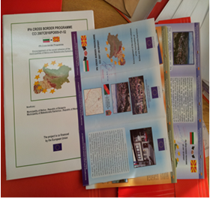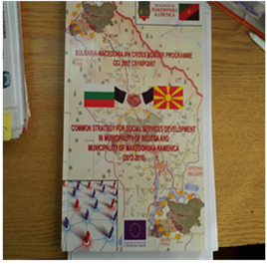

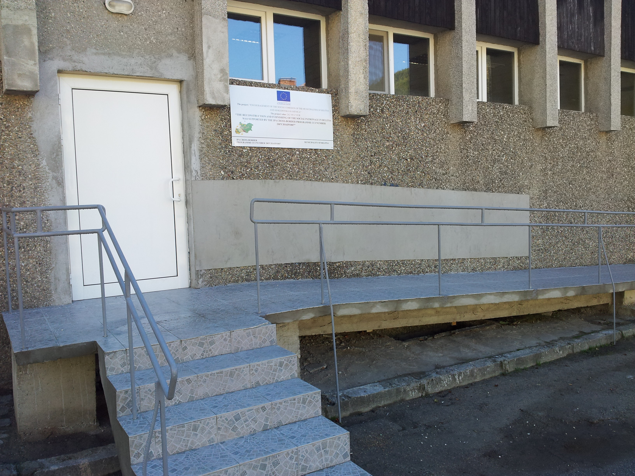

Social Patronage in Belitsa,

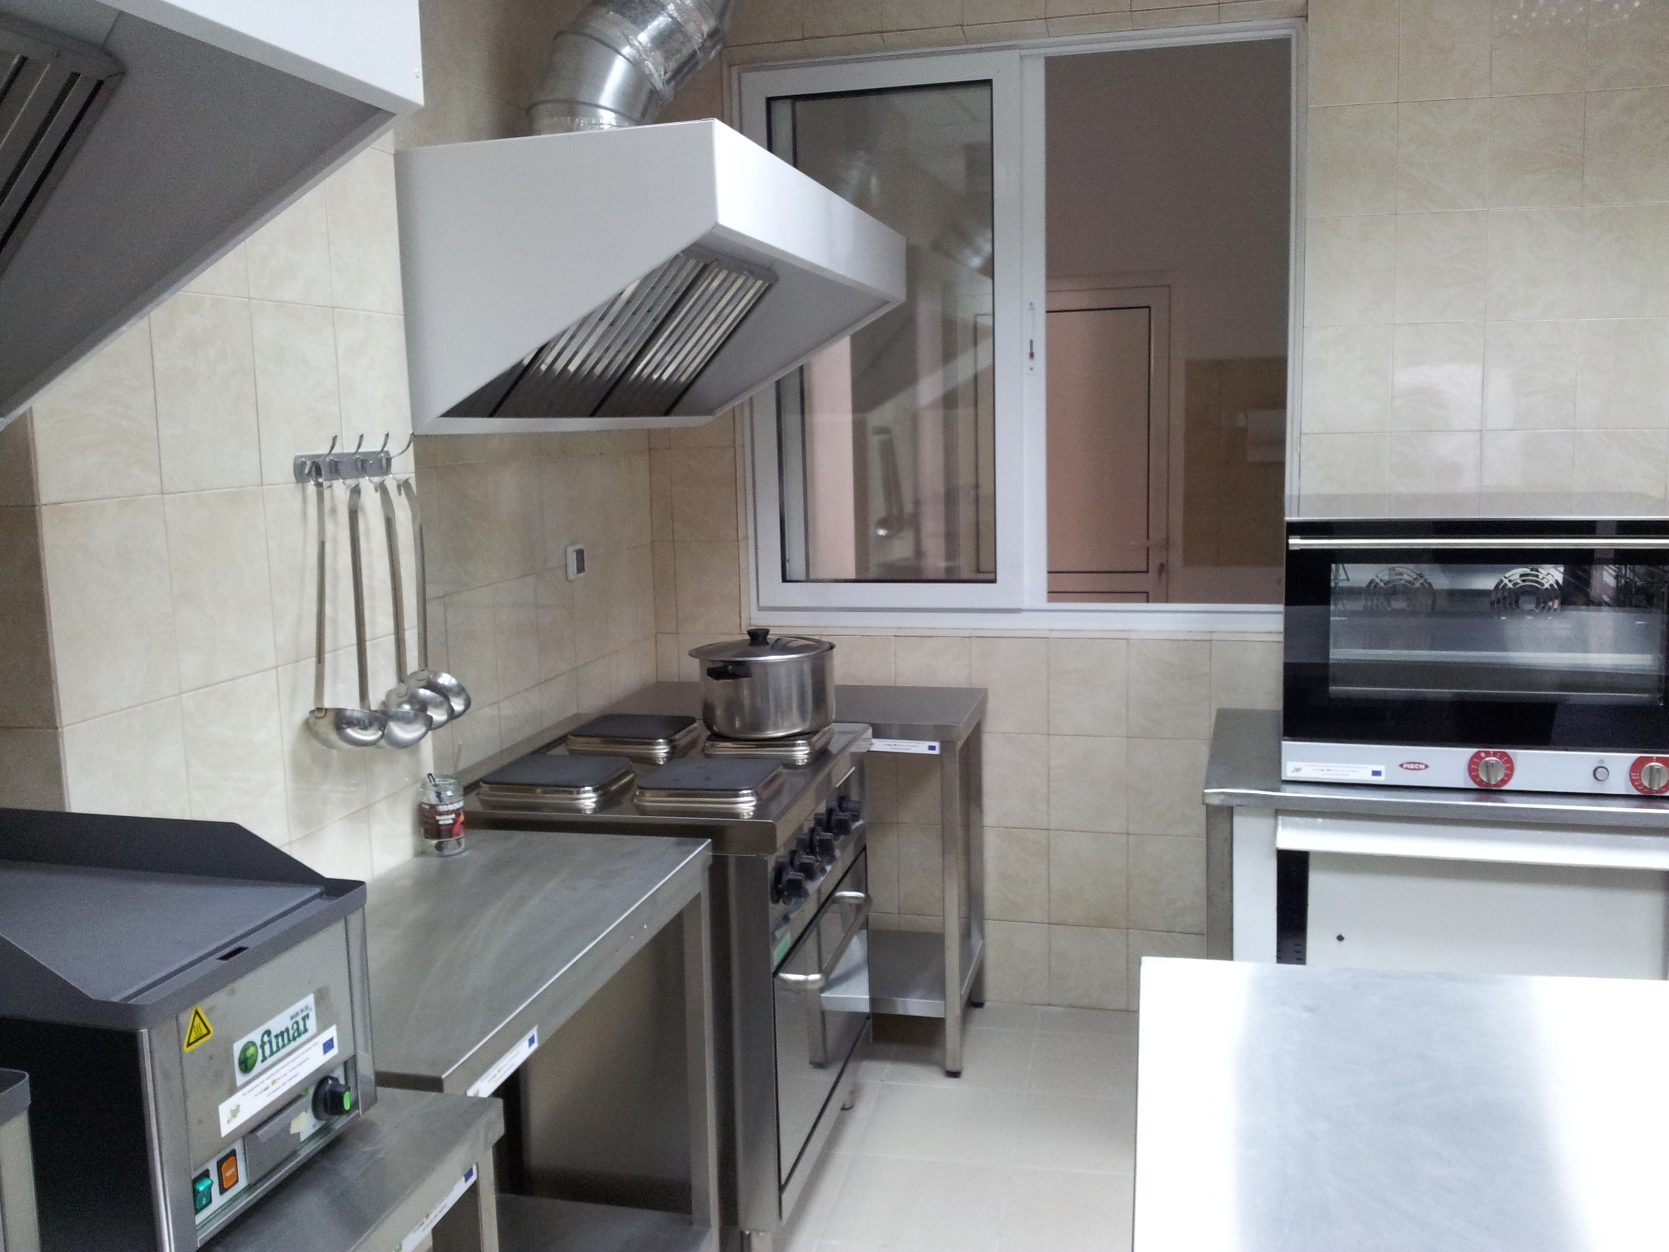

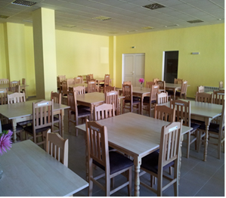

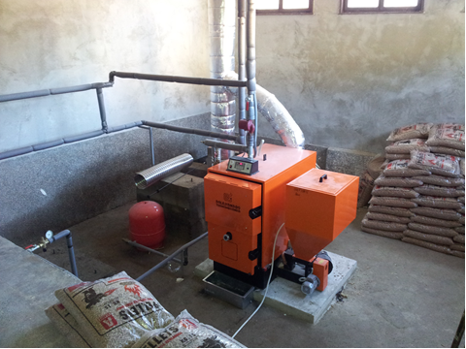

Social Patronage in Makedonska Kamenica, FYROM;

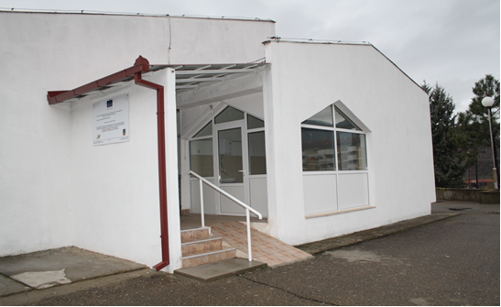

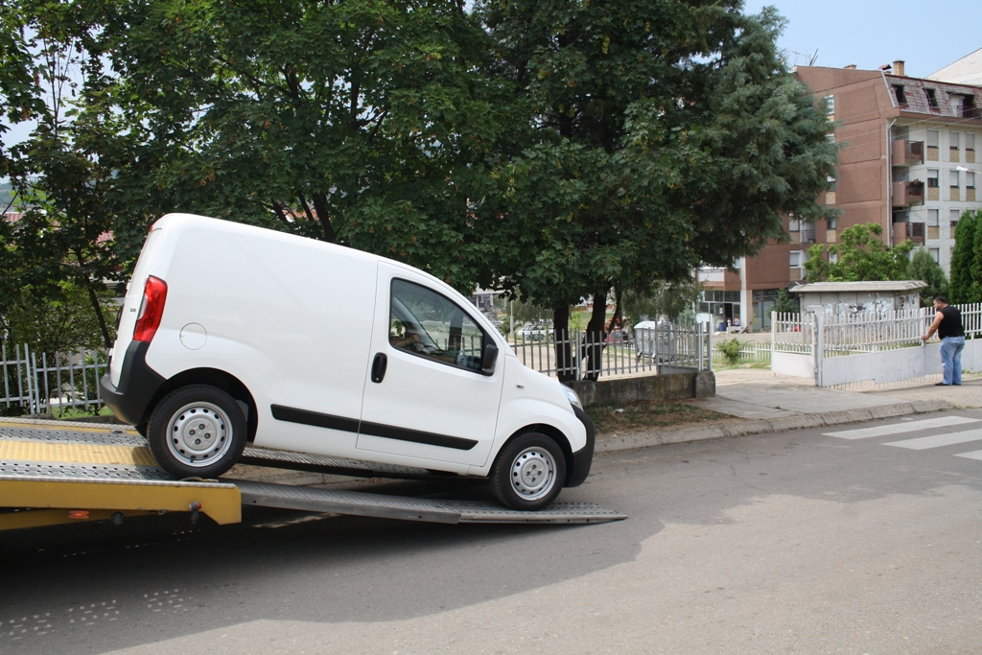

Vehicle for the Social Patronage in Makedonska Kamenica, FYROM.

