Project title: | Balkan Workshop for Theatre
Lead Partner: | Dramatic Theatre - Kyustendil
Partners: | Municipality of Stip
Duration: | 11 months
Total budget (in €) | 69 380.05 Euro
Achieved results:

1. Selected young artists: 15 Bulgarian and 15 Macedonian youth trained in “Balkan Workshop for Theatre";
2. Research and collection of fairy tales with the hero “Clever Peter”. 60 young research participants with increased awareness of similar cultural roots; children’s illustrations of fairy tales, creation of puppets and a theatrical set;
3. Organized cultural exchange weekends and 2 opened exhibitions of children’s illustrated favorite fairy tales/comics and handmade puppets in the premises of Dramatic Theatre – Kyustendil and in the Home of culture “Aco Shopov”, Stip.
4. Elaborated puppets and theatrical sets; rehearsals, music creation for theatrical performance “Clever Peter”;
5. Implemented 2 premiere and 4 additional puppet theatrical performances “Clever Peter” in Bulgarian and Macedonia – realized by theatrical trained 15 Bulgarian and 15 Macedonian youth;
6. Production of 53-min. long documentary film of the work atmosphere of the collaborative and independent work of the youth; public presentation of project results.
7. Elaborated and distributed promotional materials:
  - 100 posters of the performance “Clever Peter”
  - 500 leaflet of the performance “Clever Peter”
  - 500 booklet about the implementation of the project
  - 50 CDs of the documentary film

The project has been successfully accomplished in 04.2012.

Research and illustrations

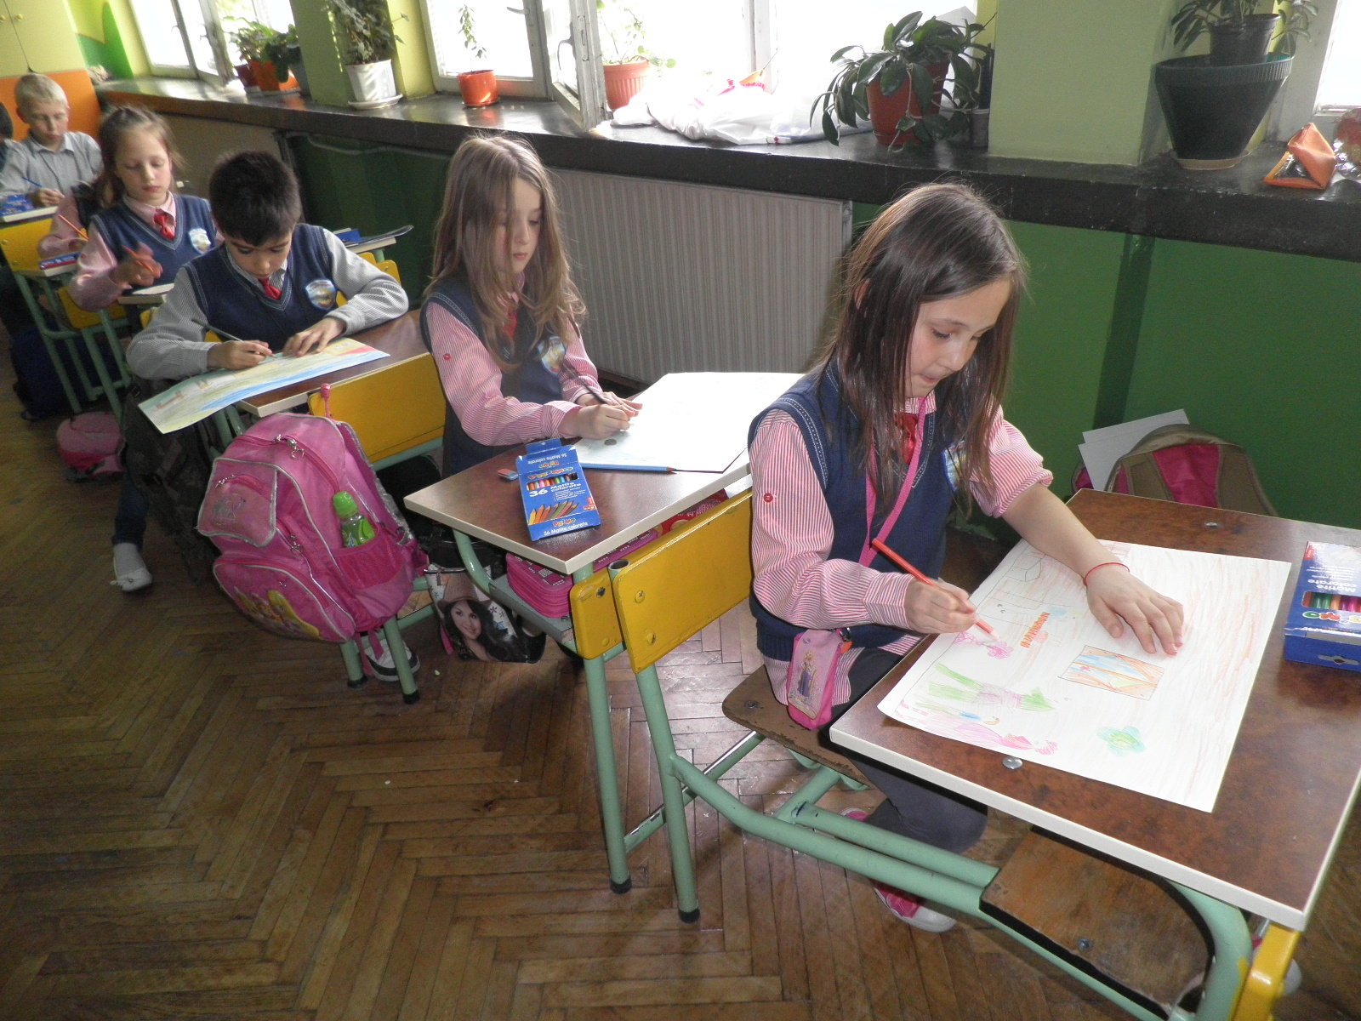

Exhibition and cultural exchange weekend in Stip

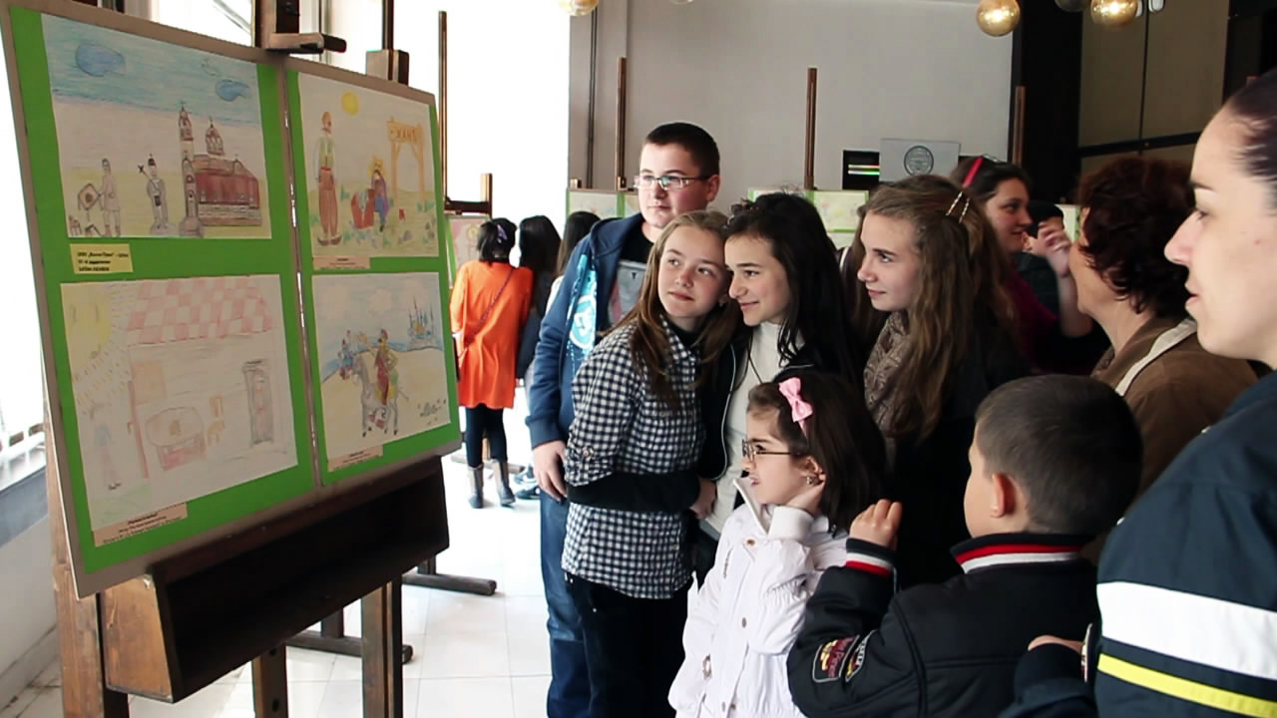

Exhibition and cultural exchange weekend in Kyustendil

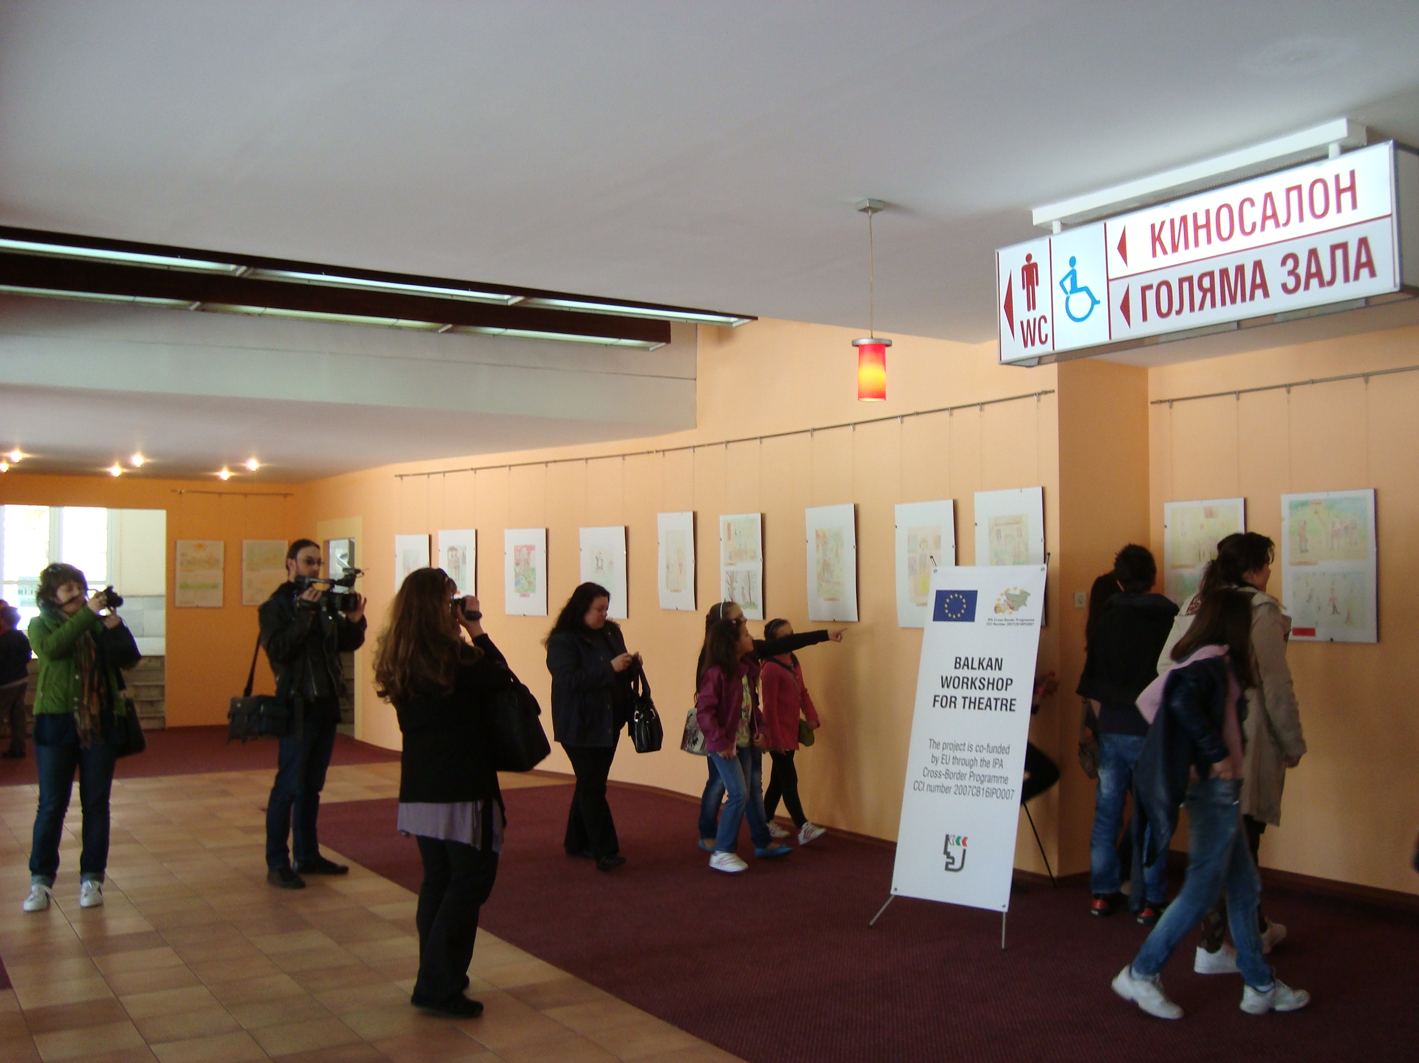

Puppet exhibition in Stip

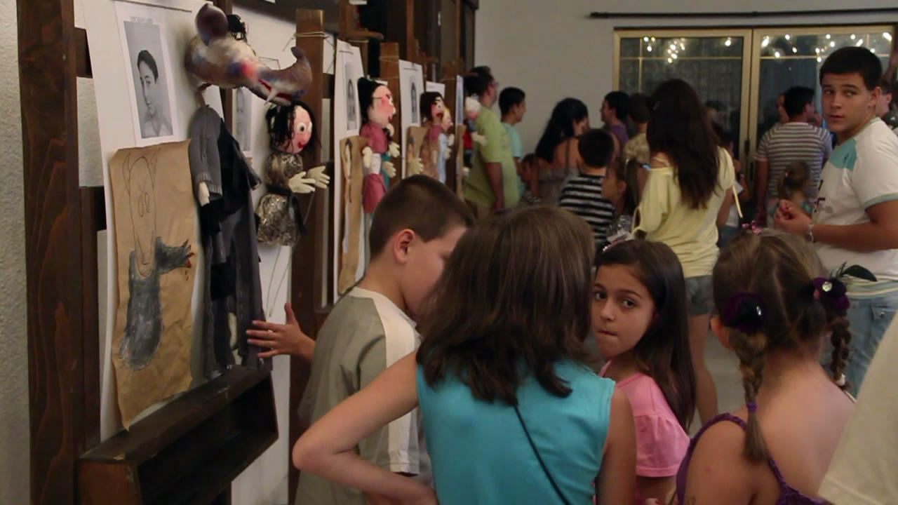

Puppet exhibition in Kyustendil
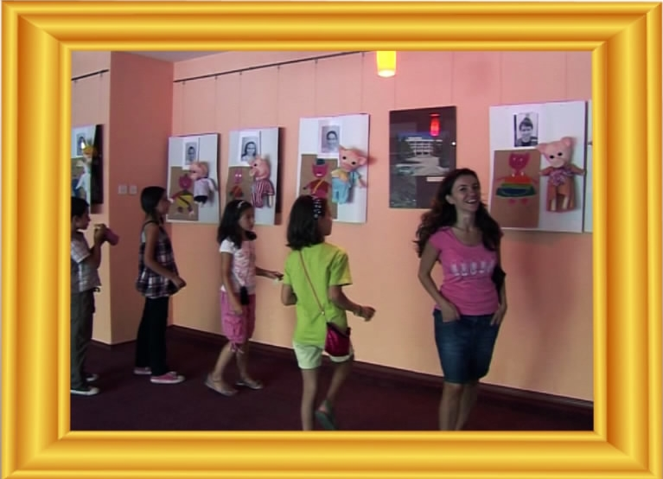

Balkan Workshop for Theatre

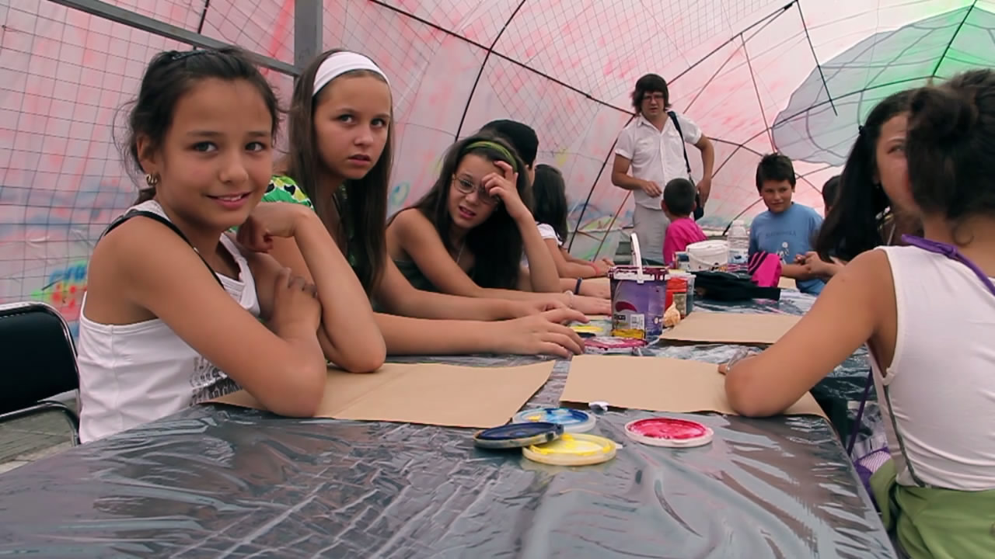

Balkan Workshop for Theatre and Rehearsals in Kyustendil and Stip

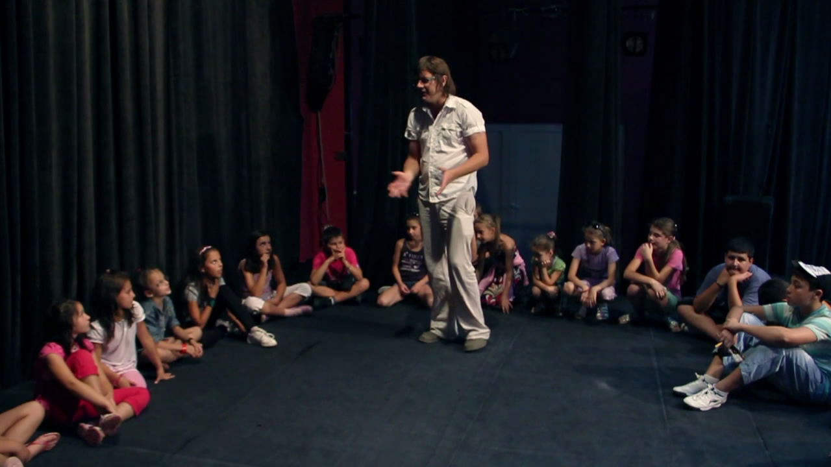

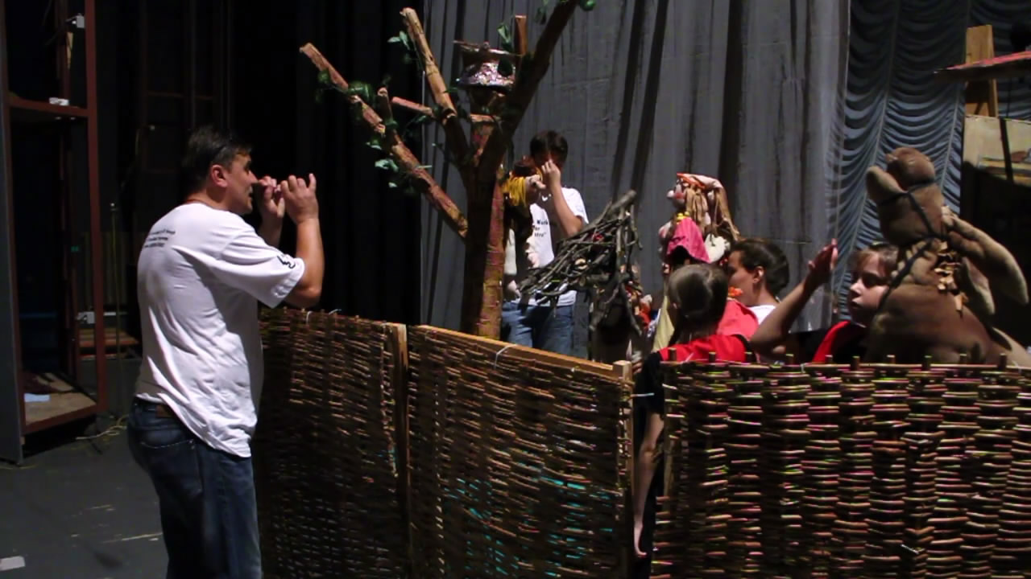

Performances in Kyustendil and Stip



