Project title: | The tourism- our common future from Struma to Bregalnica
Lead Partner: | Municipality of Simitli Republic of Bulgaria
Partners: | Municipality of Karbinci, FYROM
Duration: | 18 months
Total budget (in €) | 285 526,64 Euro
Achieved results:
As a result of the project it was created as follows:
- 1 new tourism infrastructure in the cross-border region through the utilisation of City park “Simitli”;
- developed one Programme for the development of tourism in the cross-border area of the Municipalities of Simitli and Karbinci;
- 30 trained persons for starting a tourist business;
- conducted two-day roundtable on topic "Management of tourism in conditions of European Integration";
- Cross-border Tourist Association;
- 10 new cross-border partnerships.
The project has been successfully accomplished in November 2012.

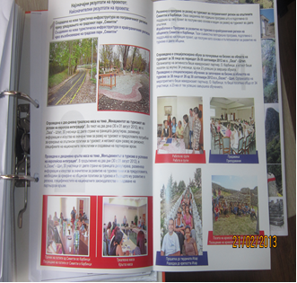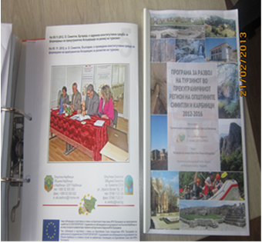

Programme for the development of tourism in the cross border area of Municipalities of Karbinci and Simitli; Information brochures;



