Project title: | Cross-border cooperation in the field of Renewable Energy Sources and Energy Efficiency (C-RESEE)
Lead Partner: | Alliance of the Producers of Ecological Energy - SOUTH  Republic of Bulgaria
Partners: | Foundation for Local and IT Development – Gevgelija, FYROM
Duration: | 14 months
Total budget (in €) | 87 562,07 Euro
Achieved results:
- Established two cross-border info and advice desks (one in Bulgaria and one in FYROM);

- Established Partnership Network for Cooperation between SMEs and branch organizations in the target cross-border region working in the field of RES and EE to aid and guide the development of SMEs of the cross-border region by encouraging investments and initiatives in this sector;

- Developed, published and distributed Cross-border business directory with information on both target regions regarding the renewable energies potential of the border regions and all the 24 municipalities from Blagoevgrad district (14) and from South-East Planning Region (10), as well as contact information of 1000 SMEs from the common cross-border region working in the field of RES and EE;

- Developed, published and distributed Info-guide on „How to invest in renewable energy in Macedonia – legislation, procedures, financing“;

- Carried out series of workshops in FYROM dedicated to renewable energies, alternative energy, energy efficiency and sustainable development;

- Carried out one contact meeting preceding the matchmaking event, where companies established contact and discussed the features of the Partnership network and the Memorandum

- Carried out one matchmaking event in support of the cross-border business cooperation between Bulgaria and FYROM in the field of RES and EE, May 11-12, 2012, Bulgaria. Signed a Memorandum for cooperation;

- Carried out one cross-border essay competition for students, that involved more than 80 participants from the target regions;

- Published and distributed 8 issues (500 copies each) of a monthly RES Bulletin.

The project has been successfully accomplished in July 2012.

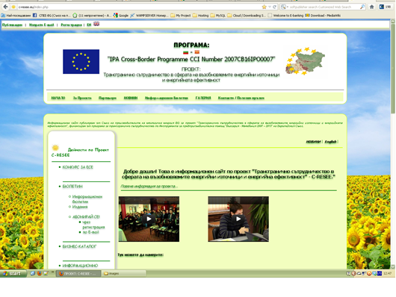
Project Website: www.c-resee.eu

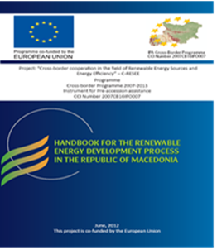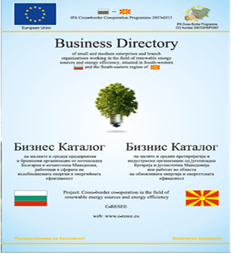
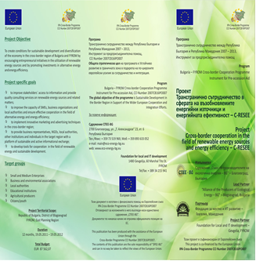
Leaflet for promoting the project C-RESEE

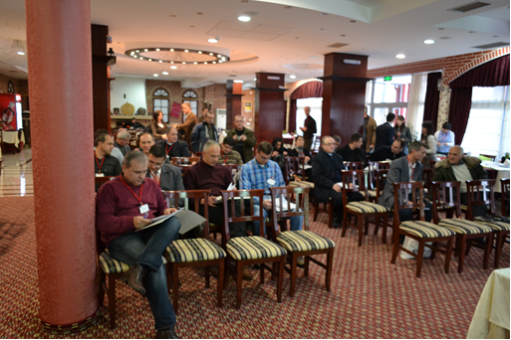
Contact meeting, FYROM – 27 – 28.01.2012 (43 participants); Gevgelija, FYROM;

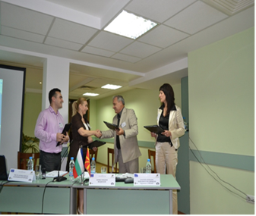
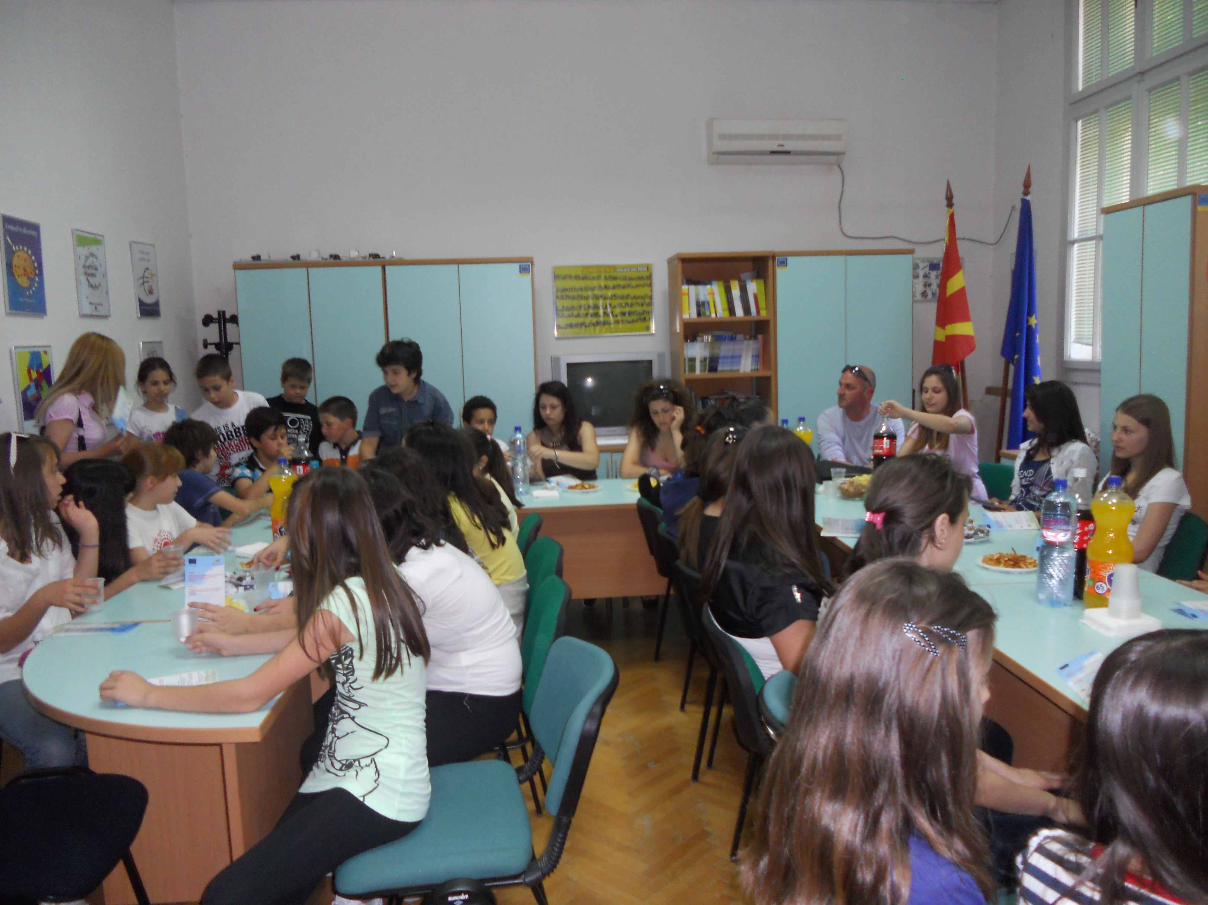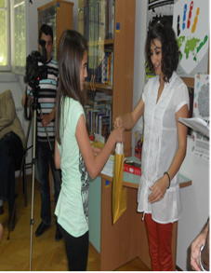

Essay competition award ceremony, FYROM– 06.06.2012; Gevgelija, FYROM

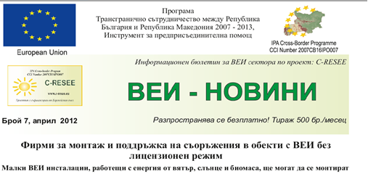

Monthly bulletin „Renewable energy news“ – paper and electronic edition

