Project title: | Promotion of rural and mountain hicking/bicycle tourism between Bulgaria and Macedonia
Lead Partner: | Women’s Organization - Stip
Partners: | Chamber of commerce and industry - Blagoevgrad
Duration: | 15 months
Total budget (in €) | 95 558 Euro
Achieved results:
- Elaborated 2 studies on the side of each project partner. Study for Business opportunities for small scale private investments in the field of rural and mountain hiking / bicycle tourism in the project region” and study for “Public transport relations in the project area”;
- Elaborated 1 project website with database of the information about the places for tourism (guest houses, restaurants, shops, hiking routes, natural, historic and cultural landmark) in project area. The database was incorporated in the project's website www.freshair-ipa.eu;
- Created common tourist product inside the project area that includes the most attractive places to visit in East region of Macedonia. As a result of this action there was crated a common tourist route, places to visit, places to rest, places to eat, shopping points, public transport schedules, etc.;
- Designed and elaborated 5 drafts for interior and exterior design of towns and villages’ outlook. Organized 2 B2B meetings;
- Trained 10 participants on the side of each project partner in the training “How to start and maintain your own tourist business”;
- Trained 10 participants on the side of each project partner in the training for sport animators.

The project has been successfully accomplished in August 2012.

Presentation of the studies on the 2nd B2B meeting in Stip, Maceodnia
•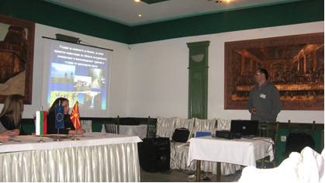
Presentation of the design drafts made in the Macedonian side, on the second B2B meeting
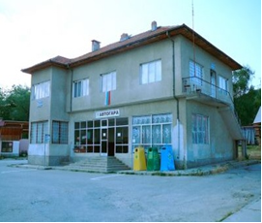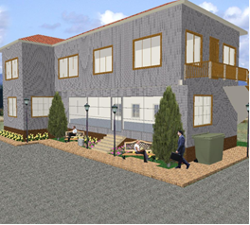
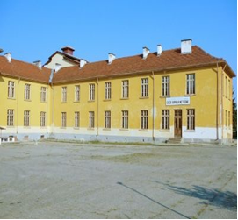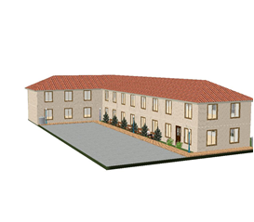

The database incorporated in the project website
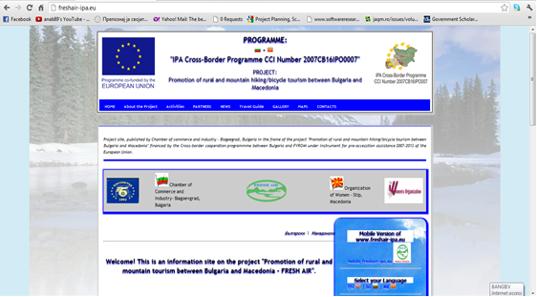

Training for entrepreneurship “How to start and maintain your own tourist business” in Stip, R.Macedonia


